HUMANITARIAN ACTION FOR "NURDOR" BY ROTARY CLUB “NIŠ-CENTER”
- BUYING MPV VEHICLE FOR TRANSPORTING CHILDREN WHO SUFFER FROM CANCER-
Dear friends,
Rotary club "Niš - Center" started a campaign to collect funds for the purchase of MPV vehicles, necessary for the transport of children from all over Serbia on therapy during the therapy.
The value of the project is € 23,325.00 (dinar equivalent), without VAT, for the purchase of vehicle
- FIAT DUCATO PANORAMA 2.3 MultiJet 130ks L1H1
We would appreciate if you consider the possibility to help in realization of this project. Your donation would be of great importance in taking children with weak immune system (due to therapy with very strong drugs) and children with disability (as a consequence of the disease) to all the therapies they need as a part of their longterm healing, because they can`t and they shouldn`t use any form of public transportation.
We have opened special-purpose accounts (dinar and foreign currency) to which you can donate funds for the purchase of the said vehicles:
dinar account 160-419996-21

Purpose of payment: Purchasing MPV vehicle for the transport of children suffereing from cancer
For payments exceeding 120,000 dinars, RK "Nis - Centre" and NURDOR will provide branding of purchased vehicles with your company logo and information about your donation on their website with link to your corporate web portal.
Momčilo Sretenović
Charter President RC "Niš - Centar" 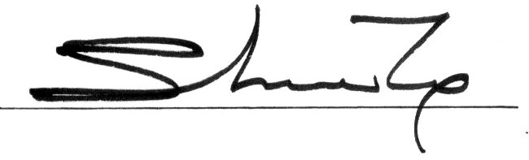
a banner on their website, with a link t

"The life gives us back, only what we give to others."

Ivo Andrić

